**What CSE 145/237D**

E4E Mangrove Monitoring - GPS and Canopy Height

**May 15, 2019**

#### **Milestone Report**

**GPS Tracking Milestones**

1. Create Sketches of GPS Device (Complete)
2. Get GPS coordinates and the Barometer on Raspberry Pi (In progress)
3. Create basic UI of GPS Software (In progress)
4. Create Laser cut drawings of front panels after parts arrive (Complete)
5. Create CAD designs for backplate of front panel (Complete)
6. Assemble device (Not Complete)
7. Optimize UI to make device much easier to use in the mangrove forests (Not Complete)

**Adjusted GPS Milestones:**

**We have adjusted schedule of milestones for the GPS project for the following reasons:**

1. The previous schedule did not fully take into account the mechanical design of making a waterproof, compact device
2. Revisions to previous mechanical designs due to a change in device enclosure, new enclosure obtained 5/15
3. The nature of already existing software for hardware implementation for

**The following changes have been made:**

Moved this milestone from Week 6 to Week 7

* Run integration tests to ensure hardware and software are communicating properly. Outcome of tests and any resulting action items will be recorded.

Week 2:

* Brainstorm and propose feasible methodologies. The ideas are proposed to the team as a whole and discussed. (Complete)
* Each team member does independent research evaluating the pros and cons of their approach. Team members keep track of notes outlining potential problems or benefits. (Complete)

Week 3:

* Commit to single methodology as a group. (Complete)
* Each team member continues doing research into the different proposed methodologies to determine which are feasible. Team members continue to compile notes of any important considerations discovered. (Complete)
* A group consensus is arrived at to determine the single approach to take. The demonstration of completion from this milestone is this document. (Complete)

Week 3/4:

* Plan out architectural components with description of entire system. As a group, break apart the design into the various components and determine the requirements of each piece. (Complete)
* Create a diagram showing how the system fits together. (Complete)

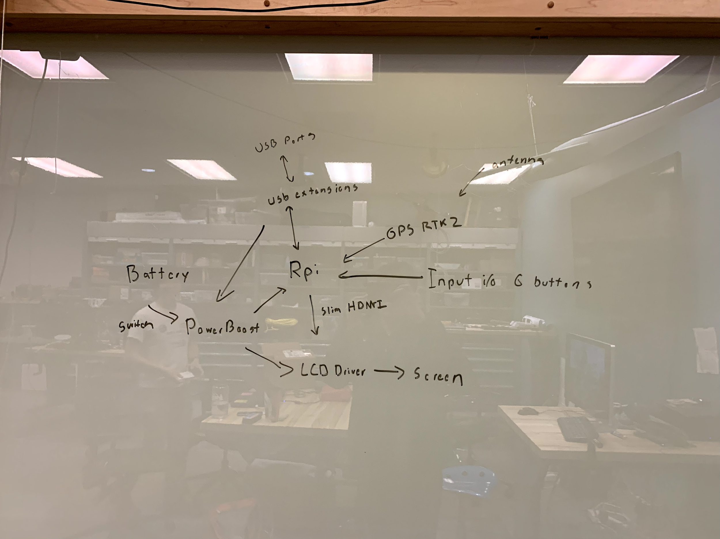

Week 4/5:

* Begin software design and implementation for non-hardware related components. Completion of this milestone entails showing any code developed to team as well as any diagrams outlining software design. (Complete)
* Obtain required materials for hardware implementation. (Complete)

Week 5/6:

* Implement the required software to interface with hardware components. (Complete)

Using PyUblox module:

<https://github.com/tridge/pyUblox>

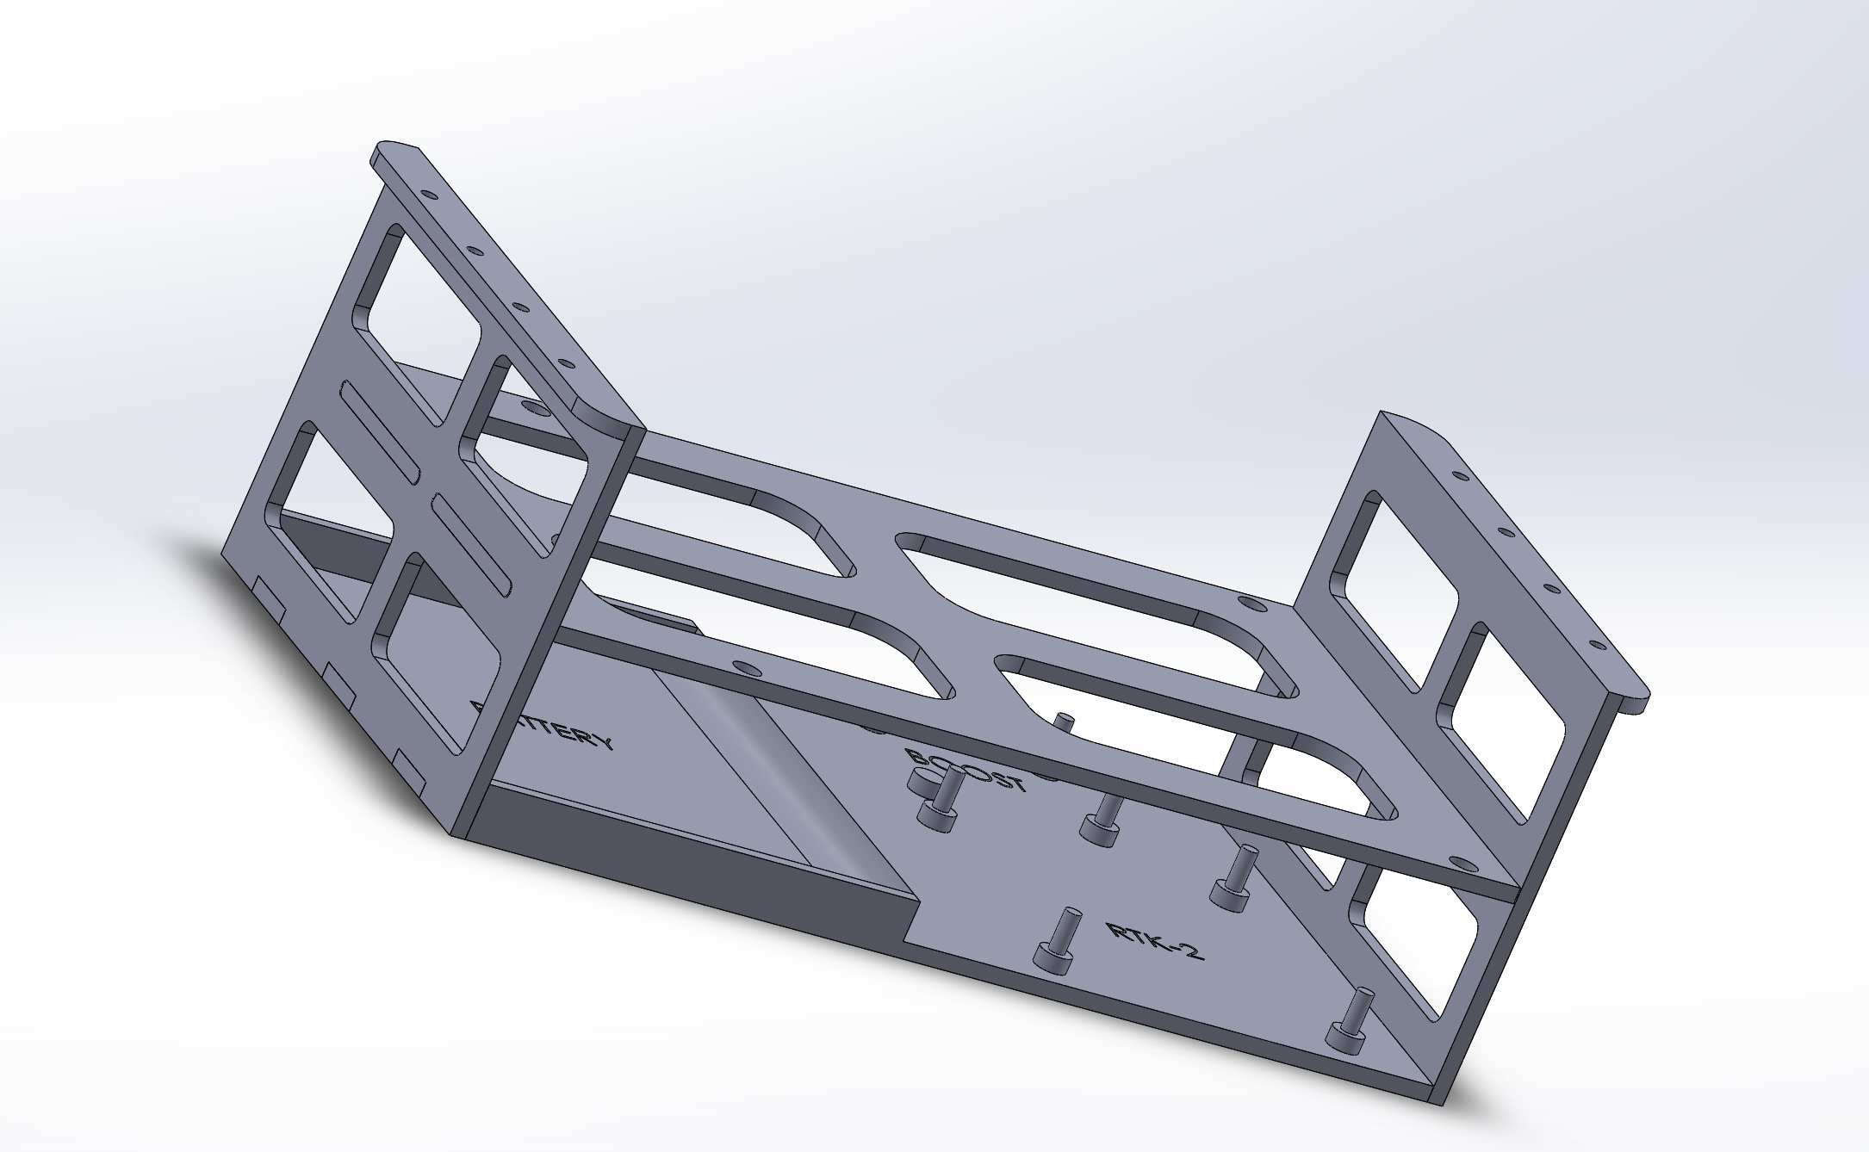

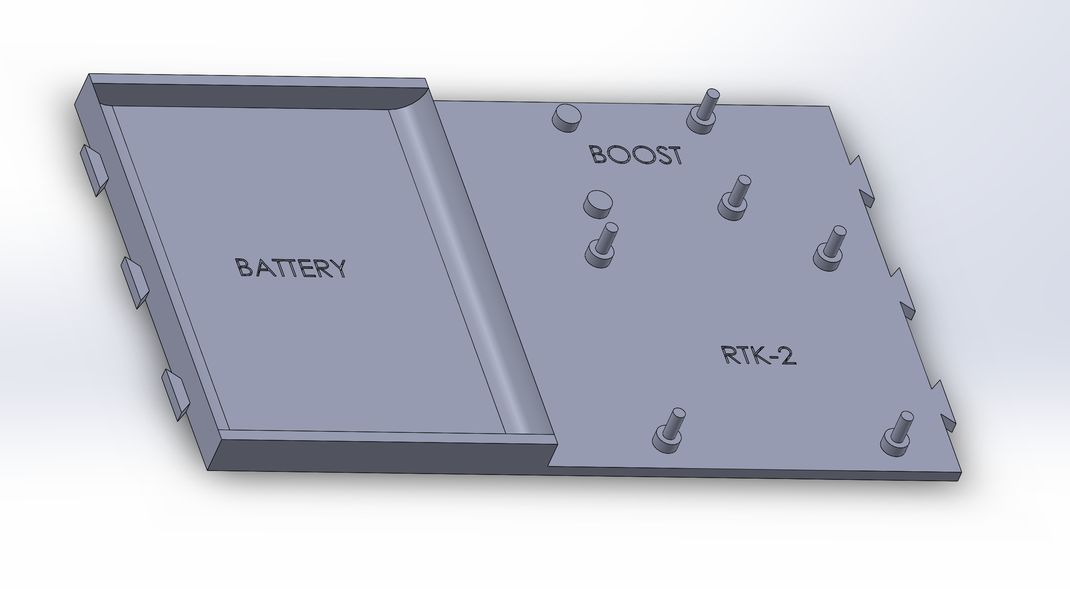

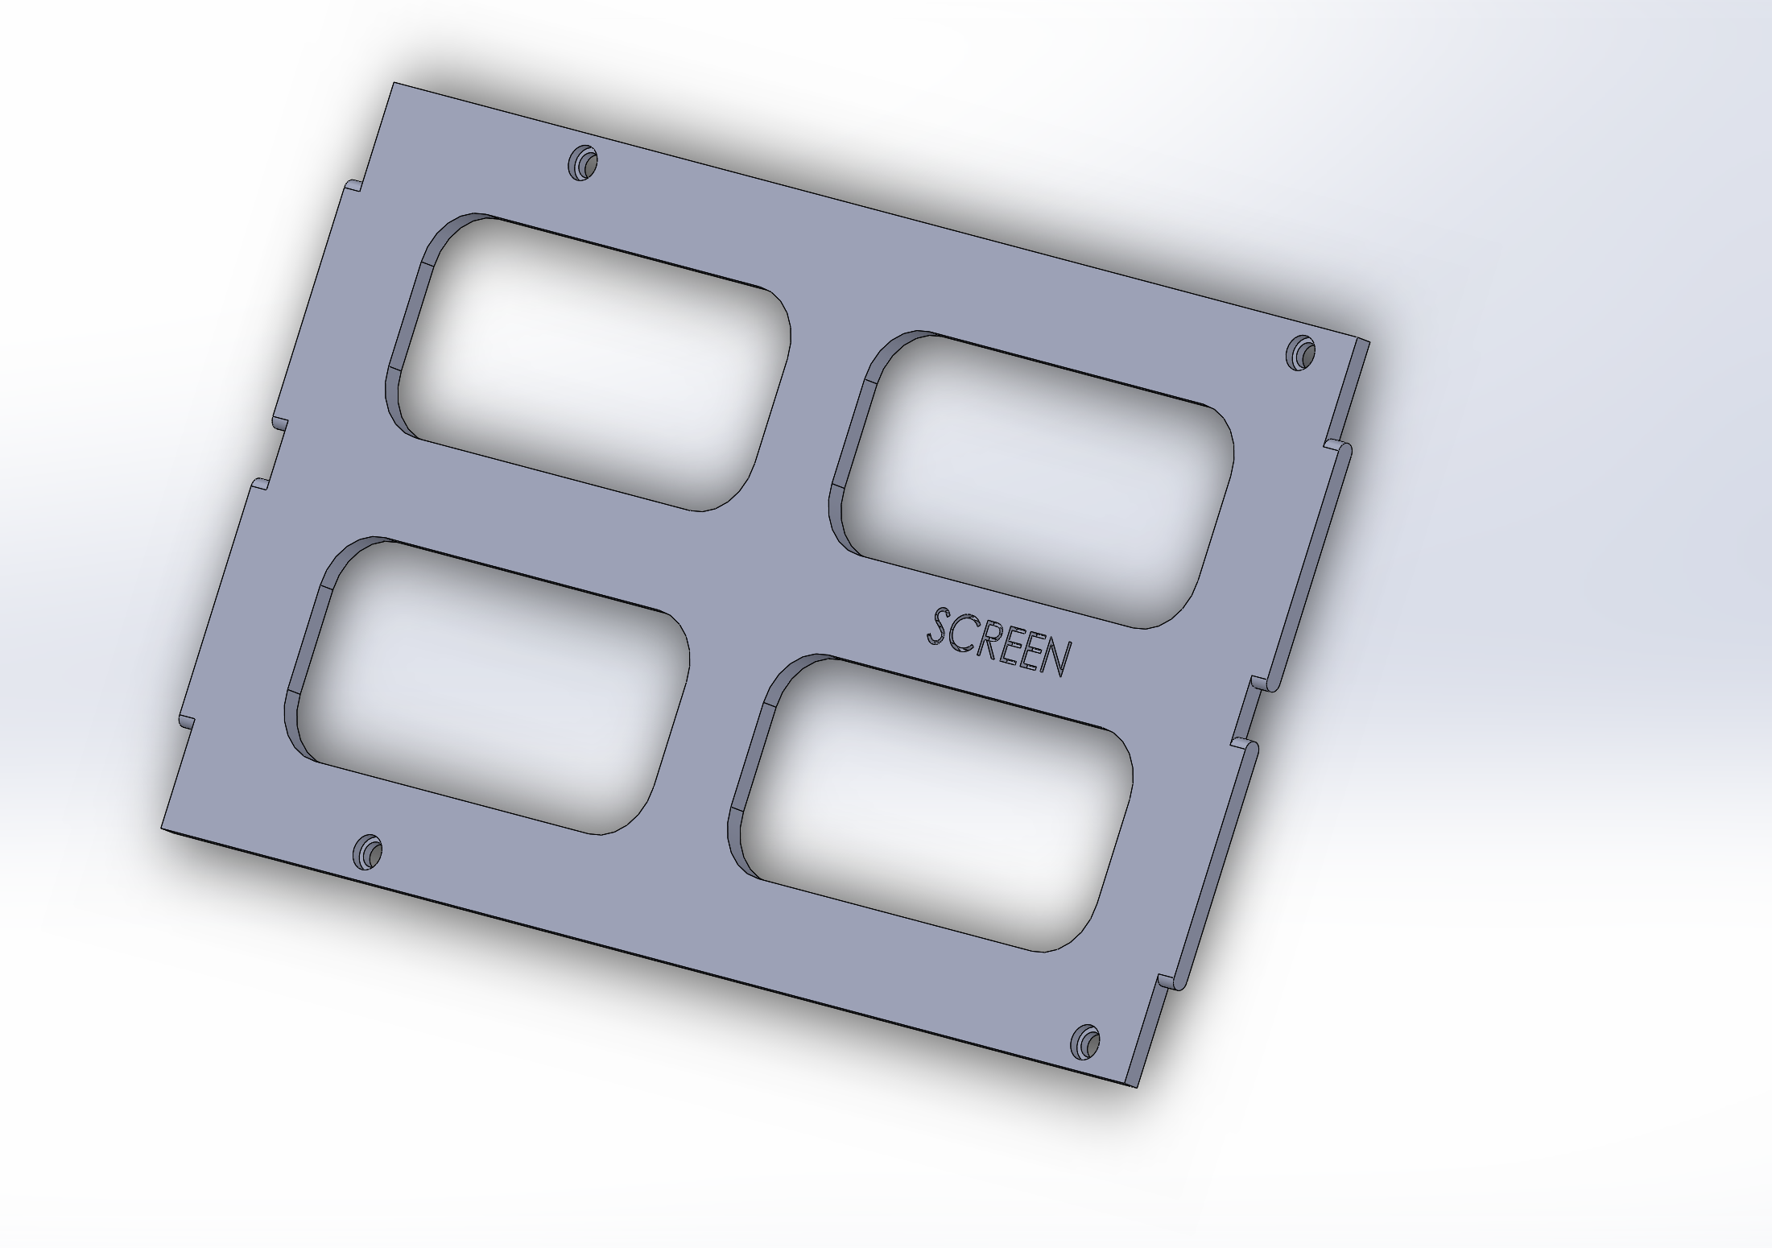

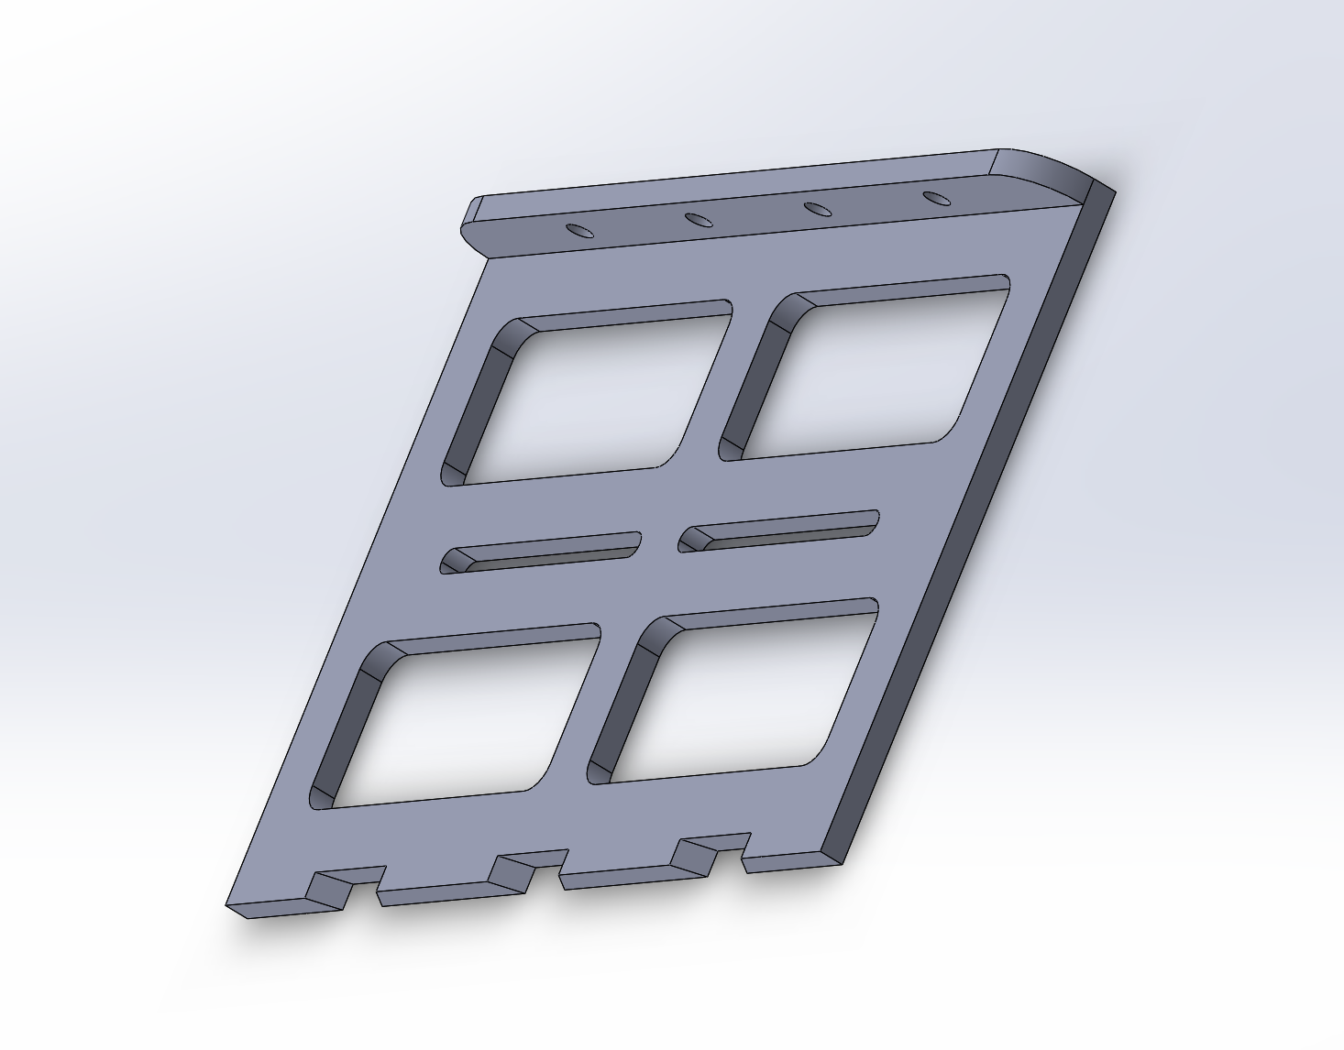

Week 7:

* Assemble all hardware and software components into the system. (In progress)
* Run system tests to ensure that the system functions as expected in a lab setting. Outcome of tests and any resulting action items will be recorded. (In progress)
* Run integration tests to ensure hardware and software are communicating properly. Outcome of tests and any resulting action items will be recorded. (In progress)

Week 8:

* Run field tests. Take the system out and ensure that it works. Outcome of tests and any resulting action items will be recorded.
  + Eucalyptus Grove, Canyon behind Warren….

Kathy and Dillon receive a B for constructing the system and testing it in the field. If the system runs correctly and document their results, they both receive an A.

Week 9:

* Complete final project report
* Prepare for final presentation video

Kathy and Dillon receive a B for finishing the report and video. They recieve an A for having a complete, robust system that works as demonstrated in the video and a detailed report of problems and solutions.

Week 10: (As time permits, useful but not high priority)

* Finalize document outlining the system and the intended usage. Provide information detailed enough to replicate the system and train a new user to utilize the system effectively.

Kathy and Dillon receive a B for writing documentation of the system. They receive an A for having a descriptive, finished written methodology that is useful for easily training users to use the GPS on their own.

Canopy Height Estimation Milestones

**Week 2:**

* Brainstorm and propose feasible methodologies. The ideas are proposed to the team as a whole and discussed.
* Each team member does independent research evaluating the pros and cons of their approach. Team members keep track of notes outlining potential problems or benefits.

Proof of Completion:

Overview presentation of proposed method, along with pros and cons and potential risks.

<https://docs.google.com/presentation/d/1psaxcWTFzoBqaBRbZAyNgrAxLc7zFhdQ9wdNlLbPXqE/edit?usp=sharing>

**Week 3:**

* Commit to single methodology as a group.
* Each team member continues doing research into the different proposed methodologies to determine which are feasible. Team members continue to compile notes of any important considerations discovered.
* A group consensus is arrived at to determine the single approach to take. The demonstration of completion from this milestone is this document (originally meant the Project Specification document, provided below).

Proof of Completion:

The Project Overview document, showing commitment to a single method for project approach, as well as the first iteration of the parts list.

<https://docs.google.com/document/d/1KOn1vG26UZ0IMBsvLXTRyIsq3j2GhV4KrnYwIMehDDY/edit?usp=sharing>

Notes on pros and cons of utilizing different hardware components and design choices:

<https://docs.google.com/document/d/1shNzt5566IchkwHt29z8sodfdpYqfpdgjeo4d38cx1I/edit?usp=sharing>

**Week 3/4:**

* Plan out architectural components with description of entire system. As a group, break apart the design into the various components and determine the requirements of each piece.
* Create a diagram showing how the system fits together.

Proof of Completion:

System Diagram

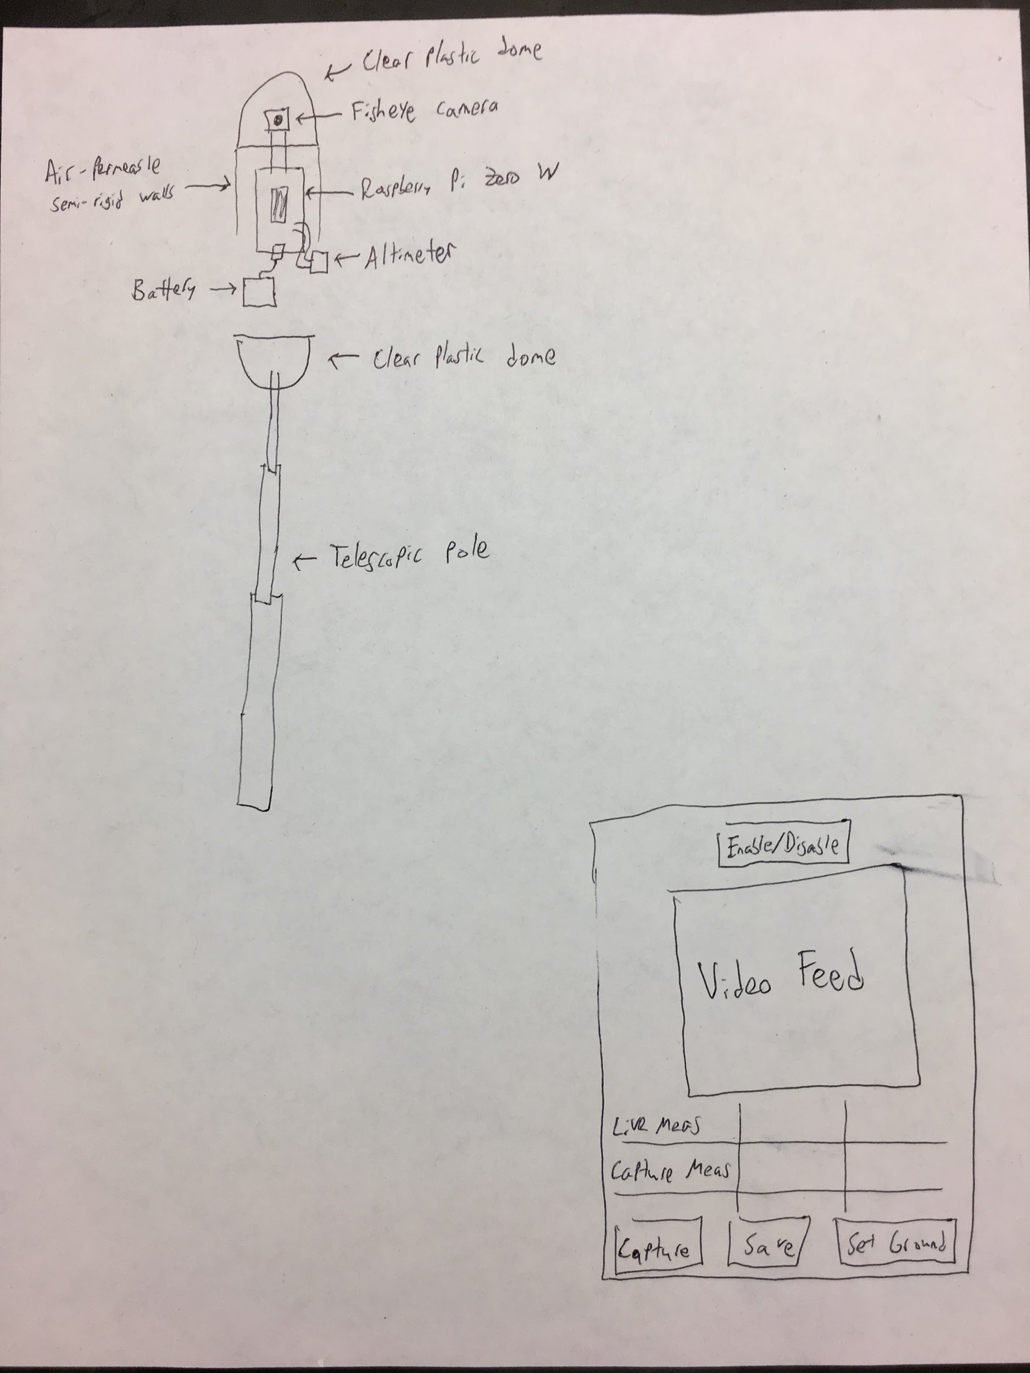

System Diagram, updated for later design changes beyond the original concept.

Notes on pros and cons of utilizing different hardware components and design choices:

<https://docs.google.com/document/d/1shNzt5566IchkwHt29z8sodfdpYqfpdgjeo4d38cx1I/edit?usp=sharing>

Finalized parts list:

<https://docs.google.com/spreadsheets/d/1YzfCWugth9ZX8ZF7Lw0C-iOLJQhxyroJRO2St3F6D-c/edit?usp=sharing>

**Week 4/5:**

* Begin software design and implementation for non-hardware related components. Completion of this milestone entails showing any code developed to team as well as any diagrams outlining software design.
* Obtain required materials for hardware implementation.

Proof of Completion:

Code for canopy height estimation project located here:

<https://github.com/UCSD-E4E/mangrove-special->

Hardware acquisition proven by the following picture, taken from the picamera attached to the raspberry pi zero w:

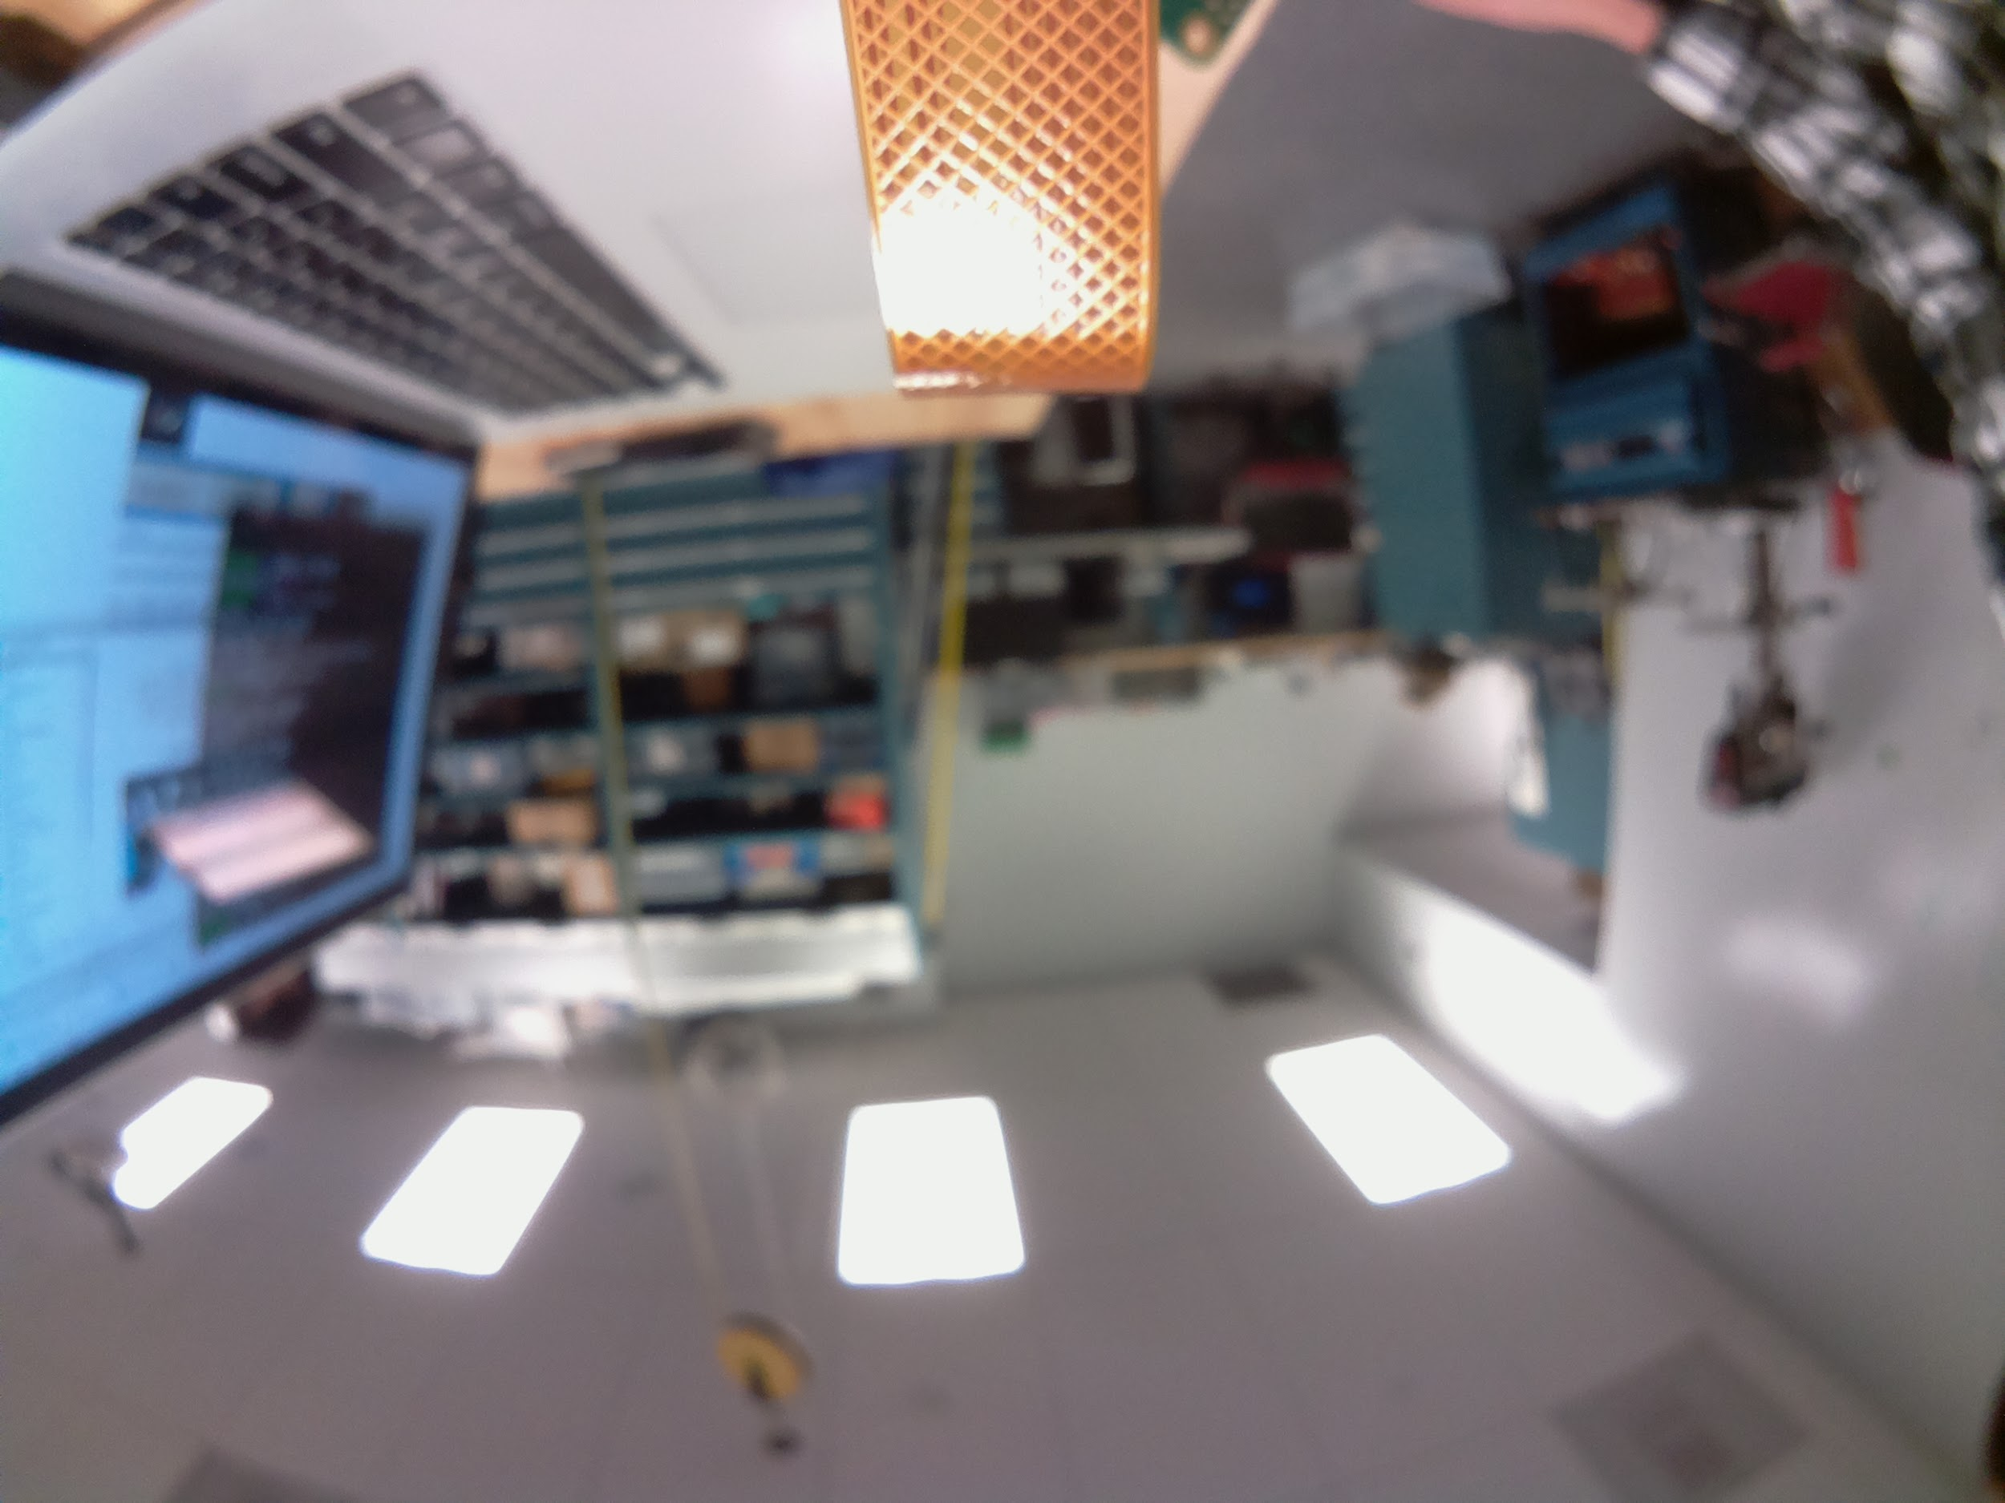

**Week 5/6:**

* Implement the required software to interface with hardware components.
* Run integration tests to ensure hardware and software are communicating properly. Outcome of tests and any resulting action items will be recorded.

Proof of Completion:

Images of the pi-hosted web page, along with the displayed measurements.

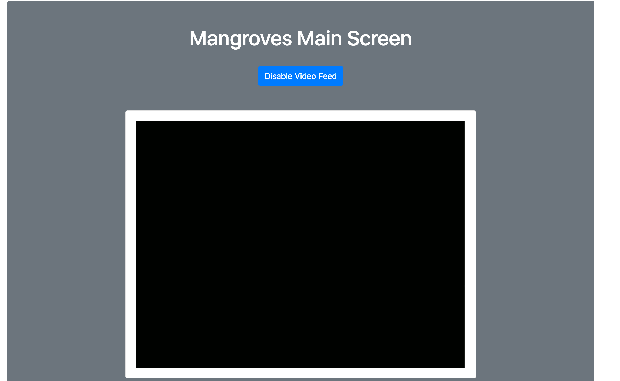

Main Screen of the Mangrove Canopy Height GUI (Video feed is black because cap is on the camera and this image was taken remotely).

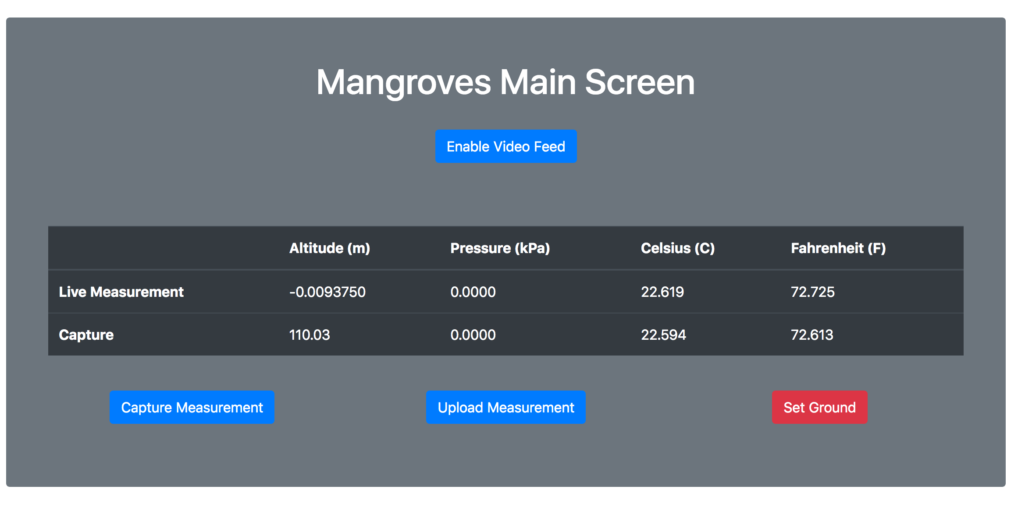

Video Feed Disabled. Live Measurement is continuously updating. Usage simulated by capturing a measurement before ground calibration was done.

Mark and Jeremy receive a B for completing the first iteration of the system, which is to have a web page hosted by the pi that can display real-time video feed and altitude measurements. They receive an A for improving upon their webpage (adding bootstrap and AJAX) and by providing additional functionalities like enabling/disabling the video feed and calibrating the altitude measurement for the ground.

**Week 7:**

* Assemble all hardware and software components into the system.
* Run system tests to ensure that the system functions as expected in a lab setting. Outcome of tests and any resulting action items will be recorded.

Proof of Completion:

Will be an image of the system fully assembled. This milestone may run into next week due to it taking longer than expected to agree upon and obtain the materials for enclosing the sensor pod.

Mark and Jeremy receive a B for planning the enclosing structure and trying out initial designs. They receive an A for showing good progress on finalizing the structure.

**Week 8:**

* Run field tests. Take the system out and ensure that it works. Outcome of tests and any resulting action items will be recorded.
  + Eucalyptus Grove, Canyon behind Warren….

Proof of Completion:

Will be a video and/or pictures of running the field tests.

Mark and Jeremy receive a B for completing the system. They receive an A for demonstrating the system works through the field tests.

**Week 9:**

* Complete final project report
* Prepare for final presentation video

Proof of completion:

Will be the final project report.

All receive a B for completing the final project report. All receive an A for starting on the final project video.

**Week 10: (As time permits, useful but not high priority)**

* Finalize document outlining the system and the intended usage. Provide information detailed enough to replicate the system and train a new user to utilize the system effectively.

Proof of Completion:

Will be the final document.

Mark and Jeremy receive a B for documenting the steps they took to build the system, including any package dependencies and the hardware components. They receive an A for providing instructions for new users to deploy and use the system, with pictures if applicable.